Hello Class!
How are you today? I am happy. Today is Wednesday 27th may and it is sunny and very hot. Do you remember the story of Breakfast at home? Today you are drawing what you have for breakfast, ok? You have some examples of typical breakfast in different countries of the world. Some vocabulary is new for you. Here you have the meaning:
(¿os acordáis de la historia de “breakfast at home? Hoy vas a dibujar lo que has tomado para desayunar, ok? Tienes varios ejemplos en el libro de desayunos típicos de diferentes países del mundo. Alguna palabra es nueva para ti. Fíjate en las imágenes)
bacon
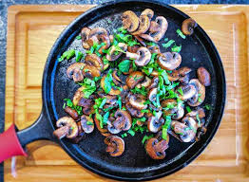
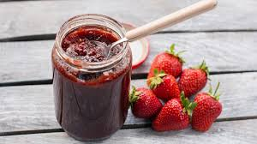
Baked beans
Fried eggs
bread
pancakes
Fried mushrooms
jam
sausages

